The effects of climate change on extreme weather

What can we expect from dangerous weather phenomena in the future, and how should we adapt to this
The Norwegian Academy of Science and Letters, Drammensveien 78, Oslo.
Tuesday September 3. 2019
18:00 – 20:00
How does a changing climate affect extreme weather events? What will characterize a centenary flood or a centenary drought by the end of this century compared to the end of the last? Moreover, how often will such extreme weather events occur in the future? Are this summer's occurrence of extreme rainfalls and last year's drought just a taste of what we have in store, and if so, how should we adapt to this?
Program
18:00 Welcome and background for today’s subject
Nils Chr. Stenseth, Chair of the Academy’s committee on Climate, Environment and
Recourses
18:15 How weather is changing with a changing climate
Peter Stott, The Hadley Center, UK Met Office
18:45 Hotter, drier and wetter summers. What will the future bring?
Jana Sillmann, CICERO Center for Climate Research
19:05 Some recent local high-impact weather events in Norway.
Do they fit in the "normal" distribution of weather events?
Jørn Kristiansen, Norwegian Meteorological Institute
19:15 Paneldebate
Panel:
Speakers
Roar Skålin, Norwegian Meteorological Institute
Erling Kvernevik, the Norwegian Directorate for Civil Protection (DSB)
Hege Hisdal, the Norwegian Water Resources and Energy Directorate (NVE)
19.50 Andreas Halse (AP) and Anne Haabeth Rygg (H) comment on how politicians make use of the available science.
20:00 End

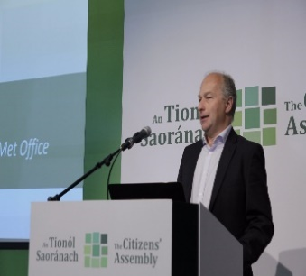
Prof. Peter Stott is Science Fellow in Attribution at the Met Office Hadley Centre and Professor of Detection and Attribution at the University of Exeter. At the Met Office he leads a team of scientists developing operational systems for attributing the causes of extreme weather events to human and natural factors. At Exeter University he supervises a PhD student developing new statistical approaches for attributing changes in climate and led a climate communication project called Climate Stories. This brought together poets, printmakers and singer-songwriters with climate scientists to develop new ways of talking about climate change.
He is a co-editor of the annual report in the Bulletin of the American Meteorological Society which explains previous extreme weather and climate events of the previous year from a climate perspective. He was Coordinating Lead Author for Chapter 10 (Detection and attribution of climate change: from global to regional) of the Working Group 1 of IPCC AR5. He has a strong involvement in public outreach including appearing in the landmark BBC1 documentary broadcast earlier this year presented by Sir David Attenborough, Climate Change: The Facts.

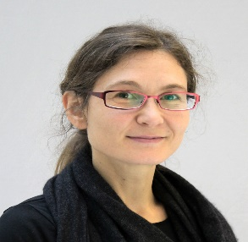
Dr. Jana Sillmann is Research Director at the Center for International Climate Research (CICERO) in Oslo, Norway and leads the Climate Impacts group. She holds a doctoral degree in Earth system sciences and is an internationally well-recognized expert in the field of climate extremes with highly cited journal articles. Dr. Sillmann is co-leading activities for the World Climate Research Program (WCRP) Grand Challenges on Weather and Climate Extremes, she is a member of the Scientific Steering Committee of the Integrated Research on Disaster Risk (IRDR) program and is a Lead author of Chapter 12 (Climate change information for regional impact and for risk assessment) in the 6th Assessment Report of the Intergovernmental Panel on Climate Change (IPCC AR6 WGI). She is further co-chairing the Development Team for the Knowledge Action Network on Emergent Risks and Extreme Events (Risk-KAN).

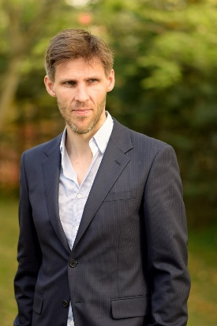
Dr. Jørn Kristiansen holds a PhD in meteorology from the University in Oslo. Since 2005 he has worked at the Norwegian Meteorological Institute (MET Norway). First as a research scientist in numerical weather prediction (NWP). In 2010 he became the leader of Yr – the world’s fifth biggest online weather service. Yr is a collaboration between MET Norway and the Norwegian Broadcasting Company (NRK). Dr. Kristiansen was integral in establishing postprocessing of the NWP data for more localized, accurate and user-centric weather forecasts. Between 2011 and 2015 he was head of the NWP division of the R&D department. He contributed to the notable achievement of establishing the unique collaboration between Finland, Norway and Sweden on an operational high-resolution ensemble prediction system for more reliable weather forecasts. As Director for the Development Centre for Weather Forecasting, he has since 2016 pushed NWP to Science for Services, organizing and leading the complete automated information chain for weather forecasting, from observations to end-users and open data, and from research to operations. Dr. Kristiansen has several national and international duties, including member of the WMO Polar Prediction Project steering group. A recent interest interdisciplinary research and end-user focused co-production that is crucial to significantly advance the provision of forecasts and their uncertainties.

